# Instructions

The marketing team has requested that each of the team members is granted access to login to the Windows system you have created previously. Set each user’s default password to Pa$$w0rd.

The list of users is as follows:

|  |  |  |
| --- | --- | --- |
| Full Name | Username | Position |
| Divya Bodine | dbdine | Marketing Manager |
| Taylor Dahl | tdahl | Marketing Manager |
| Williams Dorsey | nwilliams | Copy Editor |
| Roy Abogye | rabogye | Copy Editor |
| Nikki Reed | nreed | Graphic Designer |
| Rama Rubino | rrubino | Graphic Designer |

Each user should be placed into a group based on their position. The Marketing Managers should be members of all groups and be given administrator access to the system.

# Screenshots

Paste the required screen shots under each description.

1. Show all the new users accounts in the computer management tool.

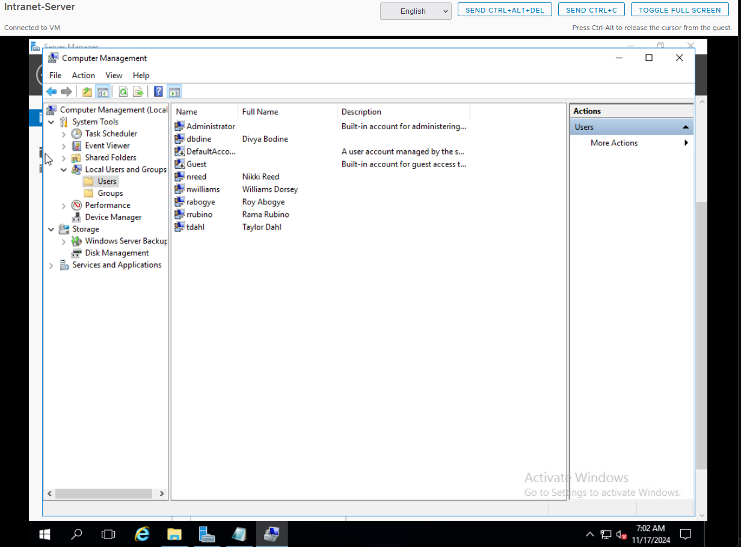

1. Show all the new groups in the computer management tool.

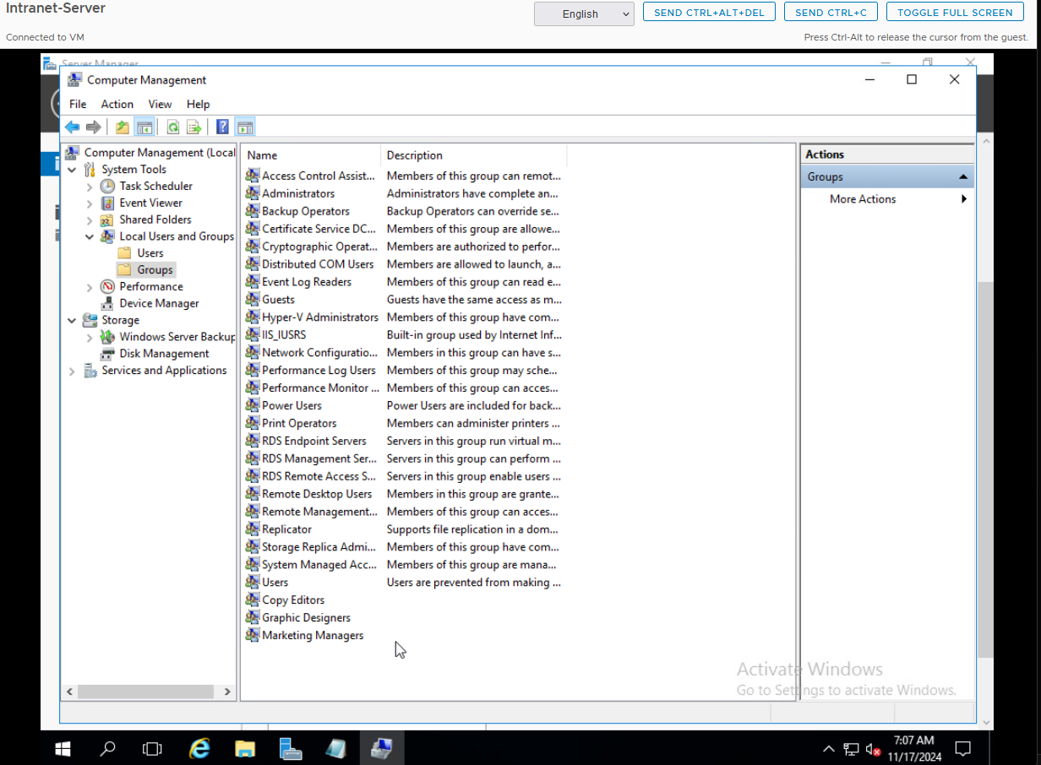

1. Show the group memberships for each group (3 screen shots required).

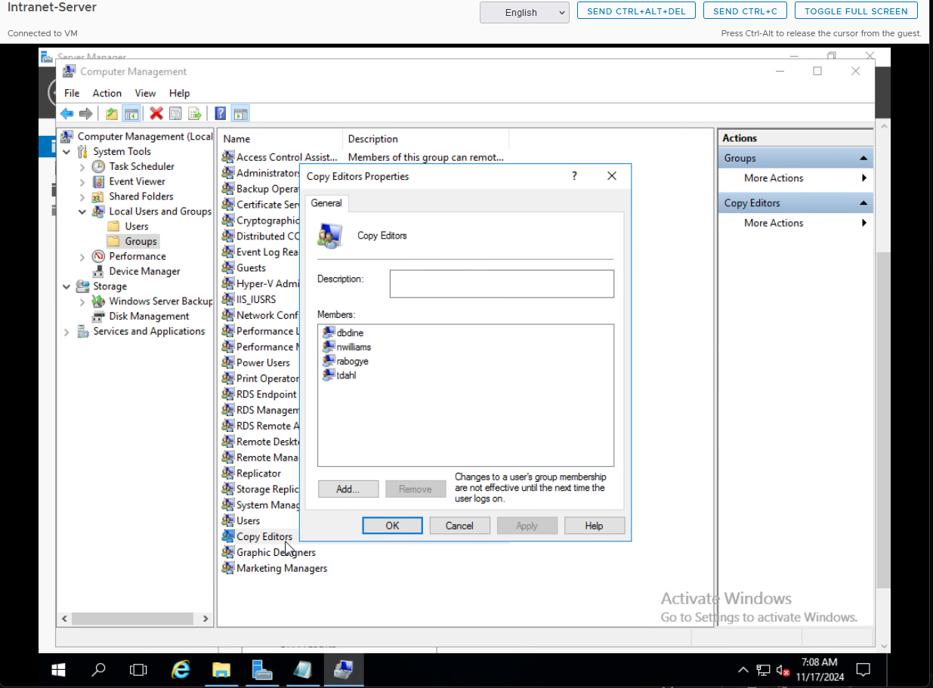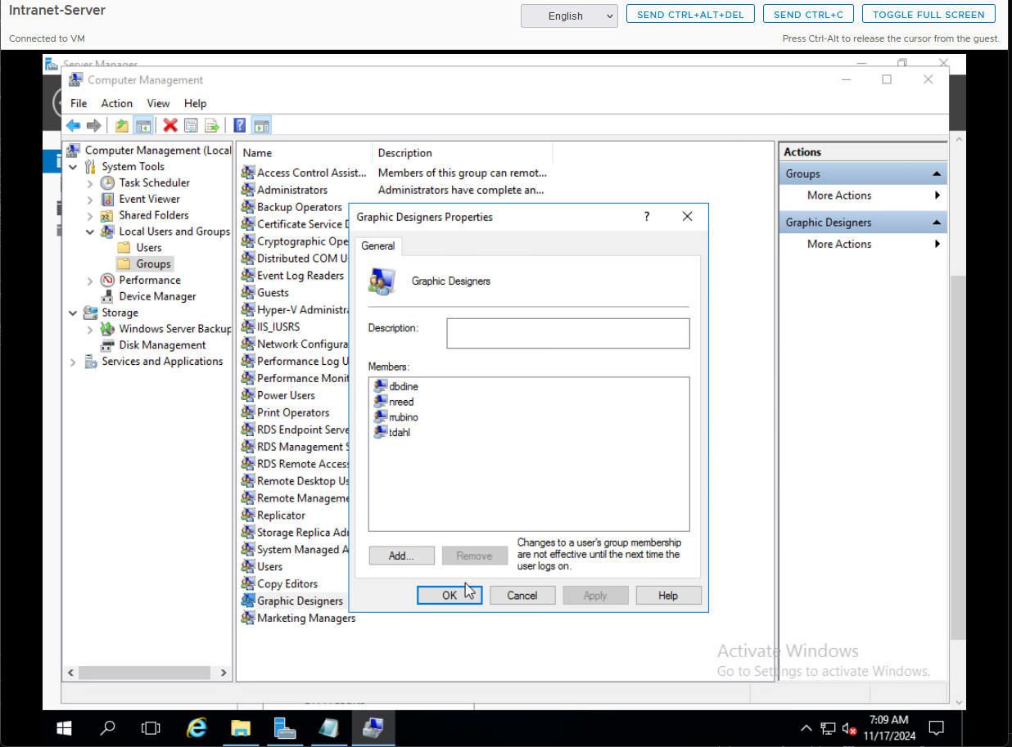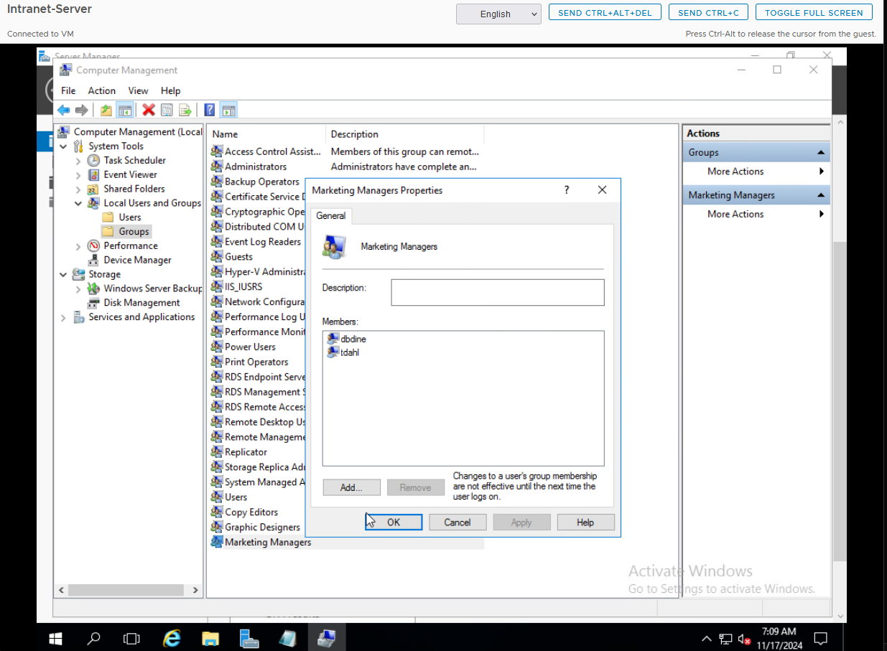

1. Show the “Administrators” group membership.

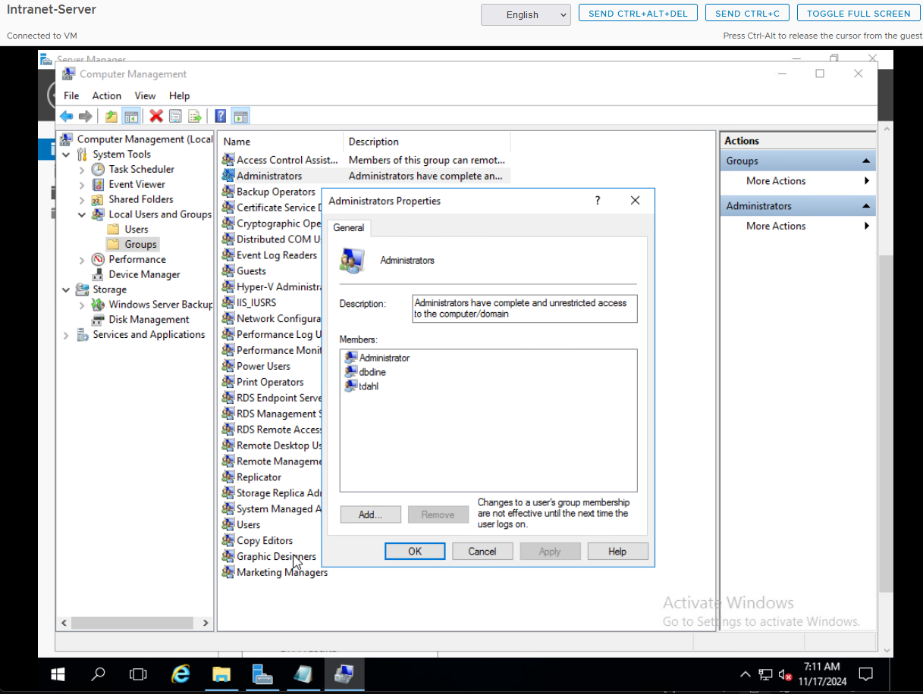

# Documentation

Record and explain all the steps you took to complete the task. Include any commands used, screen shots showing GUI interfaces, or any other information that would help you recreate the task.

**Note: You will be allowed to use this documentation to help you complete future assignments.**

Opened Computer Management from Server Manager under the Tools menu.

Expanded Local Users and Groups and selected Users.

Right-clicked in the blank space and selected New User.

Entered the username, full name, and set the default password to Pa$$w0rd for each user:

Divya Bodine (dbdine)

Taylor Dahl (tdahl)

Williams Dorsey (nwilliams)

Roy Abogye (rabogye)

Nikki Reed (nreed)

Rama Rubino (rrubino)

Unchecked the option User must change password at next logon to keep the default password active.

Clicked Create and repeated the process for all users.

Selected the Groups option under Local Users and Groups in Computer Management.

Right-clicked in the blank space and selected New Group.

Created the following groups:

Marketing Managers

Copy Editors

Graphic Designers

Double-clicked each group to open its Properties window.

Clicked Add to include members in each group:

Added dbdine and tdahl to the Marketing Managers group.

Added nwilliams and rabogye to the Copy Editors group, along with dbdine and tdahl.

Added nreed and rrubino to the Graphic Designers group, along with dbdine and tdahl.

Opened the Administrators group under Local Users and Groups in Computer Management.

Clicked Add and included dbdine and tdahl in the Administrators group.